Your Help is Our Foundation!

YES!
I want to join the Royal LePage Shelter Foundation to help women and children safely escape violence. 100% of my donation helps this cause as Royal LePage covers all operating costs.

I would like to donate the following:

Charitable Registration Number: 882531304 RR0001
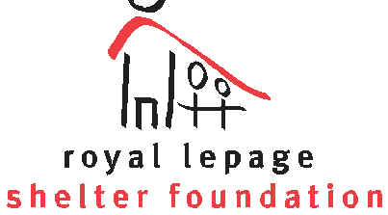

$20 can provide much needed school supplies for a child who escaped a violent home

$30 can supply a mom and her baby a kit with all the basics a newborn needs

$50 can provide two women access to education, training, financial and housing assistance workshops

$100 can feed a mom and her child three nourishing meals a day for one month

$ Name:
Address:

Phone: Email:
Have a question? Email shelterfoundation@royallepage.ca

Visa Mastercard Expiry:
MM/YYYY

Card #: Name on Card:

Signature:

The Royal LePage Shelter Foundation issues tax receipts in February for all donations you made the previous calendar year.

Your Help is Our Foundation!

YES!
I want to join the Royal LePage Shelter Foundation to help women and children safely escape violence. 100% of my donation helps this cause as Royal LePage covers all operating costs.

I would like to donate the following:

Charitable Registration Number: 882531304 RR0001

$20 can provide much needed school supplies for a child who escaped a violent home

$30 can supply a mom and her baby a kit with all the basics a newborn needs

$50 can provide two women access to education, training, financial and housing assistance workshops

$100 can feed a mom and her child three nourishing meals a day for one month

$ Name:
Address:

Phone: Email:
Have a question? Email shelterfoundation@royallepage.ca

Visa Mastercard Expiry:
MM/YYYY
Card #: Name on Card:

Signature:

The Royal LePage Shelter Foundation issues tax receipts in February for all donations you made the previous calendar year.

